# Section 4.5: Derivatives and the Shape of a Graph

Recall that if a function $f$ has a local extremum at a point $c$, then $c$ must be a critical point of $f$. However, a function is not guaranteed to have a local extremum at a critical point.

## The First Derivative Test

**First Derivative Test**

Suppose that $f$ is a continuous function over an interval $I$ containing a critical point $c$. If $f$ is differentiable over $I$, except possibly at point $c$, then $f(c)$ satisfies one of the following descriptions:

1. If $f^{'}$ changes sign from positive when $x<c$ to negative when $x>c$, then $f(c)$ is a local maximum of $f$.
2. If $f^{'}$ changes sign from negative when $x<c$ to positive when $x>c$, then $f(c)$ is a local minimum of $f$.
3. If $f^{'}$ has the same sign for $x<c$ and $x>c$, then $f(c)$ is neither a local maximum nor a local minimum of $f$.

The figure below summarizes the main results regarding local extrema:

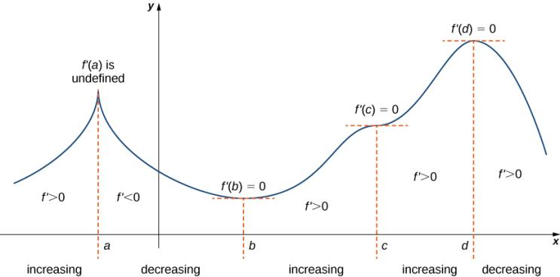

The function $f$ has four critical points: $a,b,c,$ and $d$. The function $f$ has local maxima at $a$ and $d$, and a local minimum at $b$. The function $f$ does not have a local extremum at $c$. The sign of $f^{'}$ changes at all local extrema.

Media: Watch this [video](https://youtu.be/B6XAMbw4CK0) example on analyzing a graph of $f'$.

**Using the First Derivative Test**

Consider a function $f$ that is continuous over an interval $I$.

1. Find all critical points of $f$ and divide the interval $I$ into smaller intervals using the critical points as endpoints.
2. Analyze the sign of $f^{'}$ in each of the subintervals. If $f^{'}$ is continuous over a given subinterval (which is typically the case), then the sign of $f^{'}$ in that subinterval does not change and, therefore, can be determined by choosing an arbitrary test point $x$ in that subinterval and by evaluating the sign of $f^{'}$ at that test point. Use the sign analysis to determine whether $f$ is increasing or decreasing over that interval.
3. Use the **First Derivative Test** and the results of step 2 to determine whether $f$ has a local maximum, a local minimum, or neither at each of the critical points.

Media: Watch this [video](https://youtu.be/kv_W7259jlY) example on the 1st derivative test for a polynomial.

Media: Watch this [video](https://youtu.be/49WwC-G4sjI) example on the 1st derivative test for a rational.

Examples

1. Analyze the graph of $f^{'}$, then list all intervals where
   1. $f$ is increasing or decreasing and
   2. the minima and maxima are located.

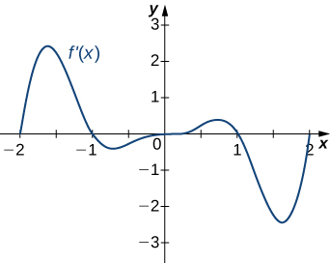

1. For each of the following, use the first derivative test to find the location of all local extrema. Then, use a graphing utility to confirm your results.

$f\left(x\right)=x^{3}-3x^{2}-9x-1$

$f\left(x\right)=5x^{\frac{1}{3}}-x^{\frac{5}{3}}$

## Concavity and Points of Inflection

Once we determine where a function is increasing or decreasing, there is another issue to consider regarding the shape of the graph of a function. If the graph curves, does it curve upward or curve downward?

Let $f$ be a function that is differentiable over an open interval $I$. If $f^{'}$ is increasing over $I$, we say $f$ is **concave up** over $I$. If $f^{'}$ is decreasing over $I$, we say $f$ is **concave down** over $I$.

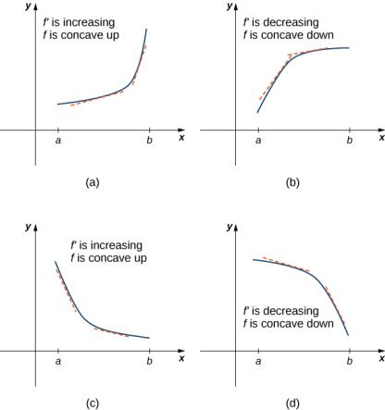

In general, without having the graph of a function $f$, how can we determine its concavity? We can determine the concavity of a function $f$ by looking at the second derivative of $f$.

**Test for Concavity**

Let $f$ be a function that is twice differentiable over an interval $I$.

1. If $f^{''}\left(x\right)>0$ for all $x∈I$, then $f$ is concave up over $I$.
2. If $f^{''}\left(x\right)<0$ for all $x∈I$, then $f$ is concave down over $I$.

Notice that a function $f$ can switch concavity only at a point $x$ if $f^{''}\left(x\right)=0$ or $f^{''}(x)$ is undefined. This is called the inflection point of $f$. However, a function $f$ may not change concavity at a point $x$ even if $f^{''}\left(x\right)=0$ or $f^{''}(x)$ is undefined.

If $f$ is continuous at $a$ and $f$ changes concavity at $a$, the point $(a, f\left(a\right))$ is an **inflection point** of $f$.

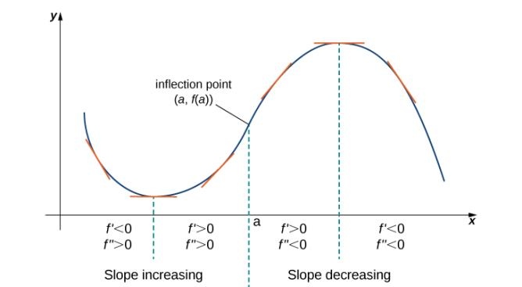

Media: Watch this [video](https://youtu.be/8IyPycrDTaA) example on analyzing a graph of $f'$ for concavity.

Media: Watch this [video](https://youtu.be/4QFj-aY3SyY) example on finding concavity and inflection points.

Media: Watch this [video](https://youtu.be/x7zLxKkqcXU) example on sketching a graph with given properties.

Examples

1. Analyze the graph of $f^{'}$, then list all inflection points and intervals $f$ that are concave up and concave down.

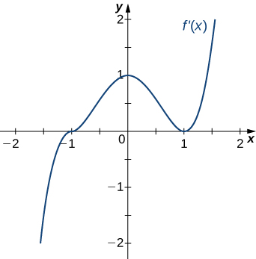

1. For the function $f\left(x\right)=x^{3}-6x^{2}+9x+30$, determine all intervals where $f$ is concave up and all the intervals where $f$ is concave down. List all inflection points for $f$. Use a graphing utility to confirm your results.
2. For the function $y=x^{3}$, is $x=0$ both an inflection point and a local maximum/minimum?
3. Draw a graph that satisfies the given specifications for the domain $x=[-3,3]$. The function does not have to be continuous or differentiable.

$f^{''}\left(x\right)<0$ over $-1<x<1$, $f^{''}\left(x\right)>0$ over $-3<x<-1$ and $1<x<3$, local maximum at $x=0$, local minima at $x=±2$

## The Second Derivative Test

The first derivative test provides an analytical tool for finding local extrema, but the second derivative can also be sued to locate extreme values. Using the second derivative can sometimes be a simpler method than using the first derivative.

**Second Derivative Test**

Suppose $f^{'}\left(c\right)=0$, $f^{''}$ is continuous over an interval containing $c$.

If $f^{''}\left(c\right)>0$, then $f$ has a local minimum at $c$.

If $f^{''}\left(c\right)<0$, then $f$ has a local maximum at $c$.

If $f^{''}\left(c\right)=0$, then the test is inconclusive.

Example: Use the second derivative test to find the location of all local extrema for $f\left(x\right)=x^{5}-5x^{3}$.